**Lab 2 Assignment**

**Exploring Oracle VM VirtualBox to create the virtual Machines**



1. **Create Two or more Virtual Machine and assign resources.**

* Click on New button on Home Page. Choose file path of OS.

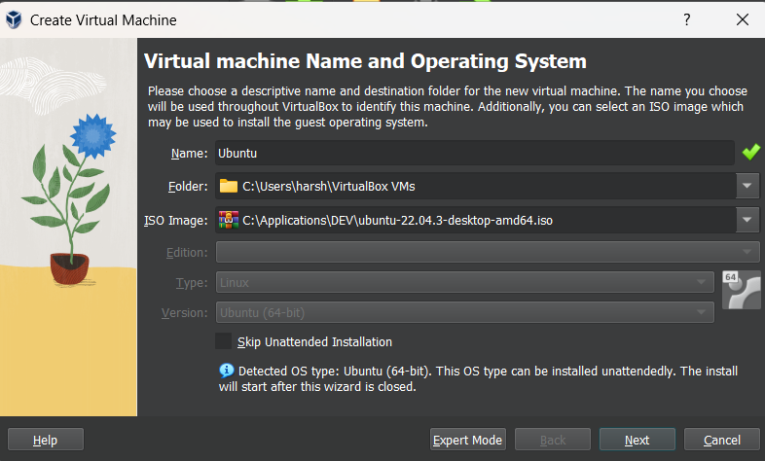

* Give User details

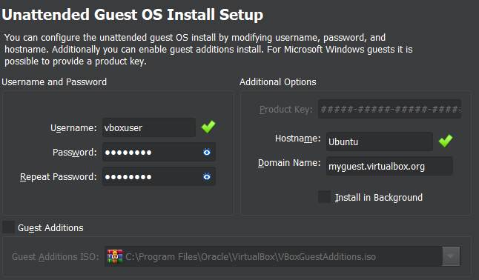

* Allocate Memory and Processors

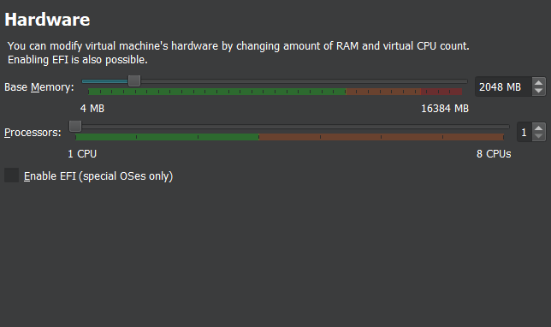

* Allocate Disk Space

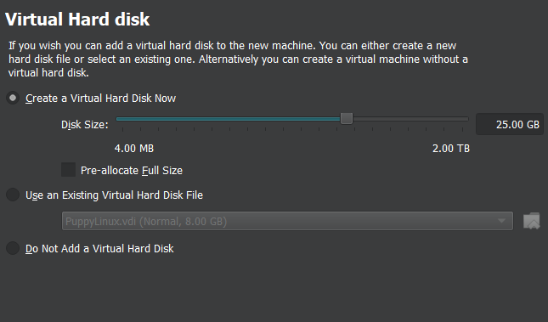

* Check Summary and click Finish. Do the same for other VM.

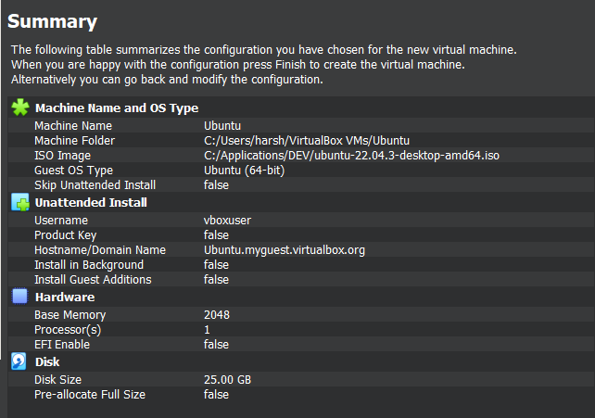 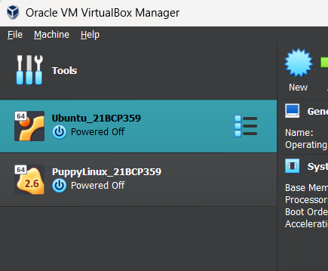

1. **Install two or more Guest Operating Systems on all the VMs**

* Click on New button on Home Page. Choose file path of OS.



* Give User details



* Allocate Memory and Processors



* Allocate Disk Space



* Check Summary and click Finish. Do the same for other VM.

 

1. **Run simple applications or programs on all the VMs.**
2. **Run a simple Python script printing even numbers in VM-1 at 5 sec intervals.**

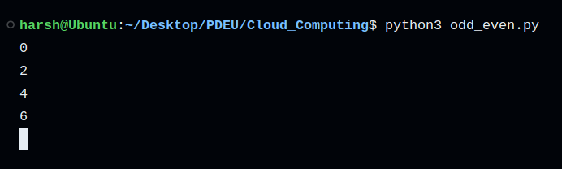

1. **Run a simple Python script printing odd numbers in VM-2 at 5 sec intervals.**

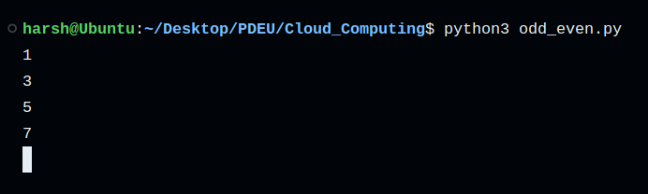

1. **View system configurations of each VM. Check whether it is same different from what you have created.**

